Clint Alonzo BSIT-3D

# Activity 2: JavaScript Review: Mini Project

Created new local repository and linked to my github. Forgot to take screenshots but I’ll just provide the screenshot of my github repo.

Created index.html, styles.css, script.js.

Index.html

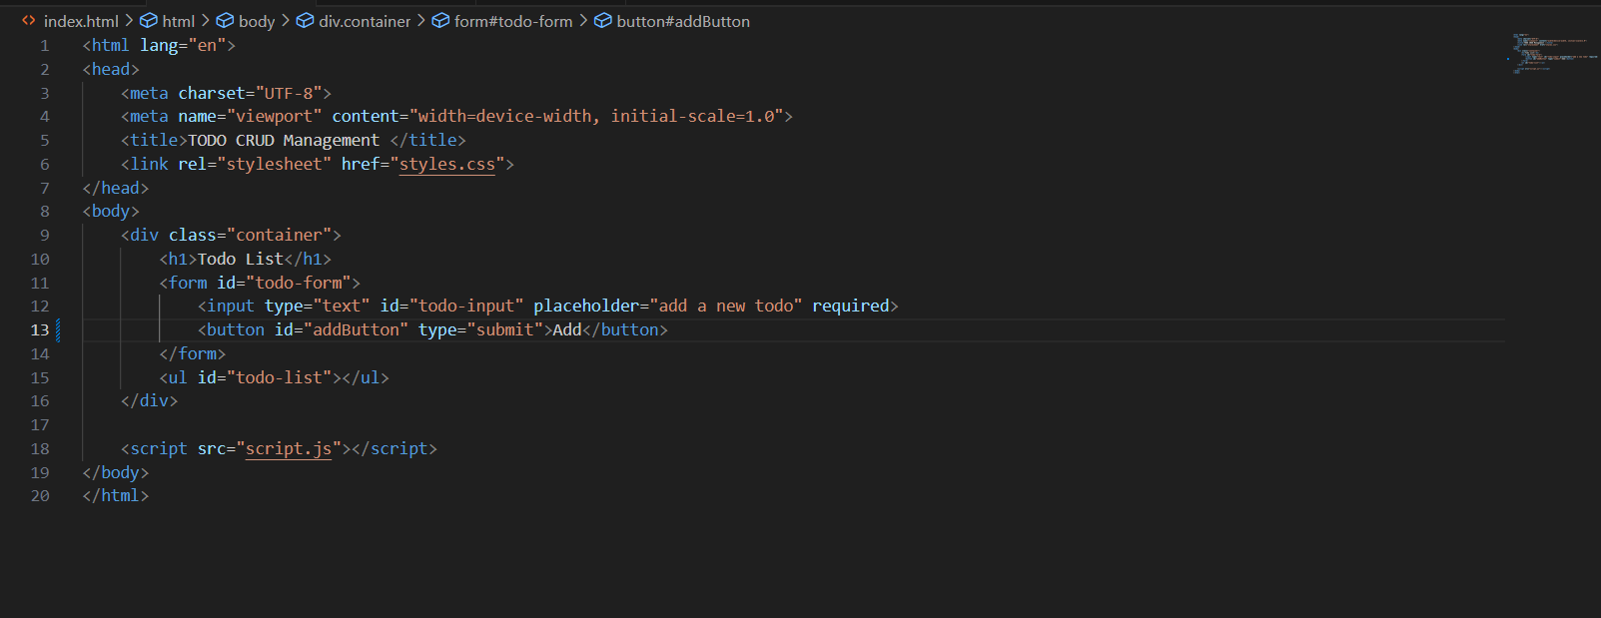

Styles.css

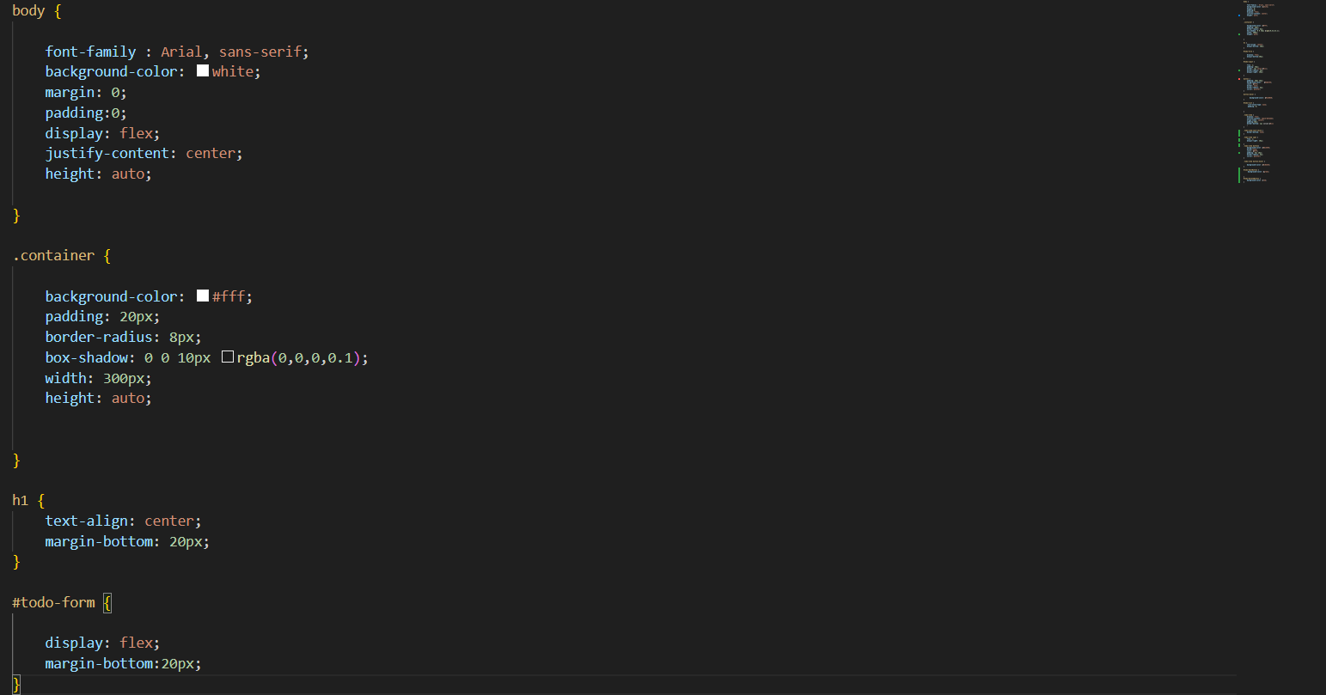

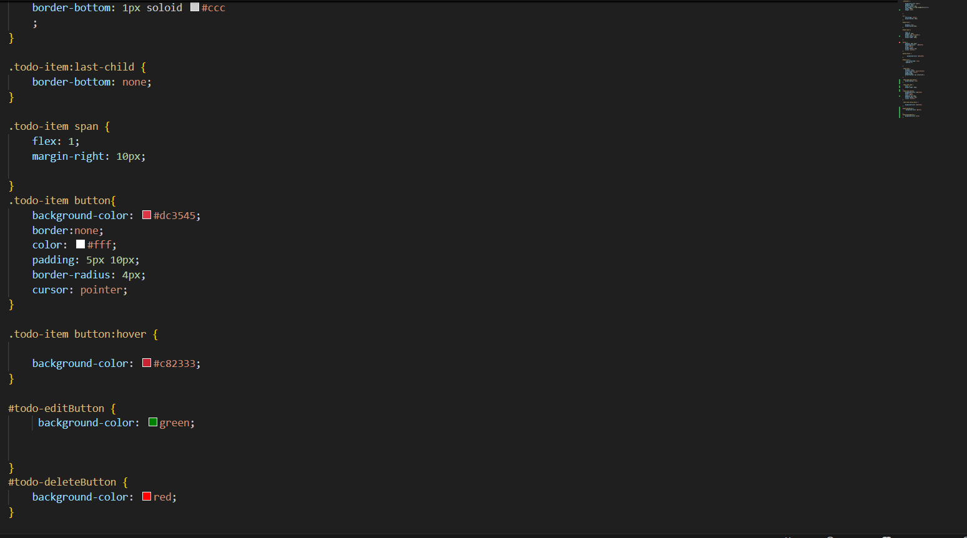

Script.js

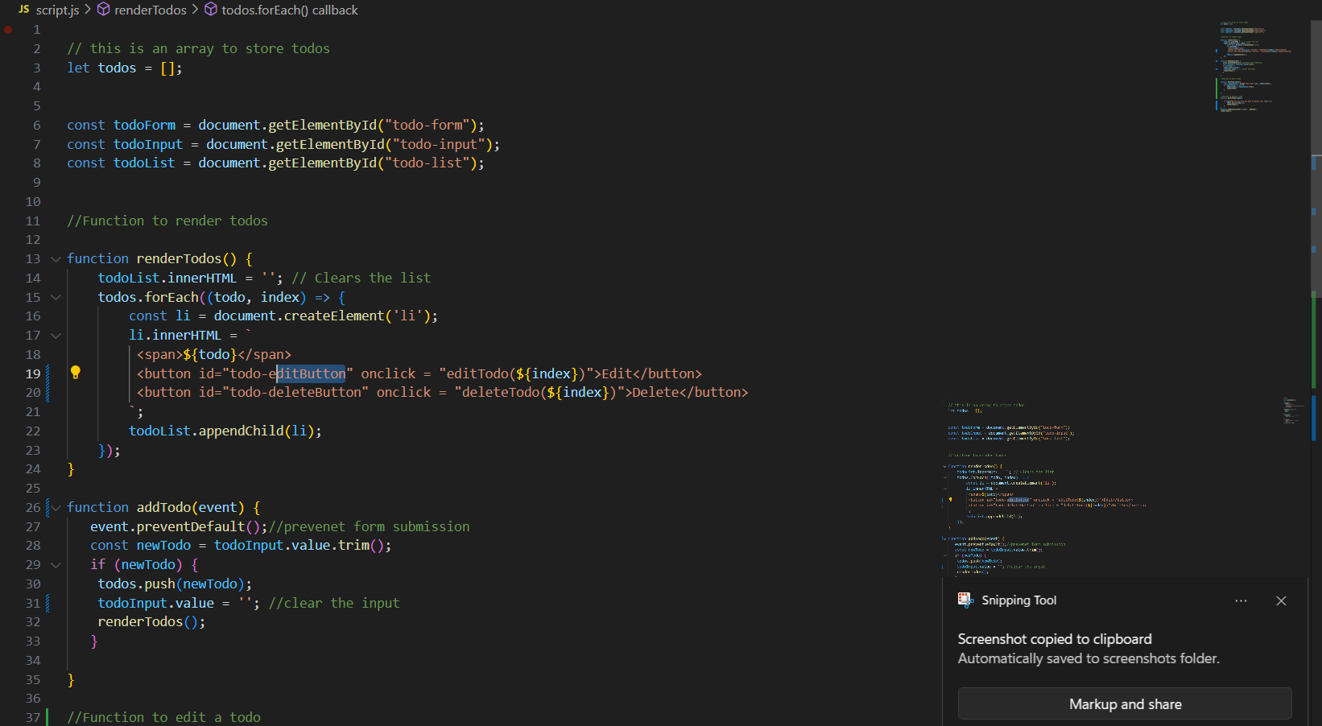

REAME.md

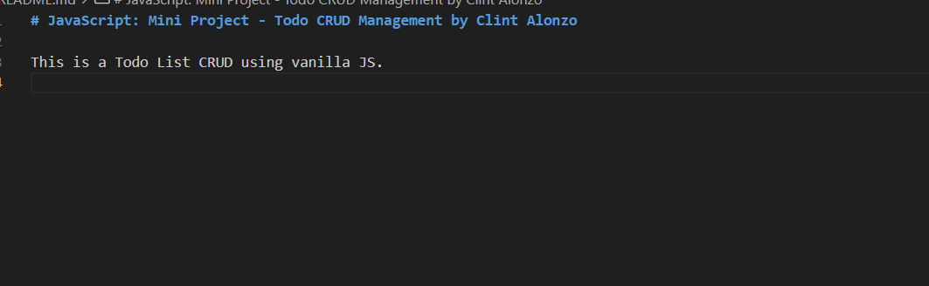

Here’s the screenshot of my repository I forgot to take screenshot of how I committed and pushed my project.

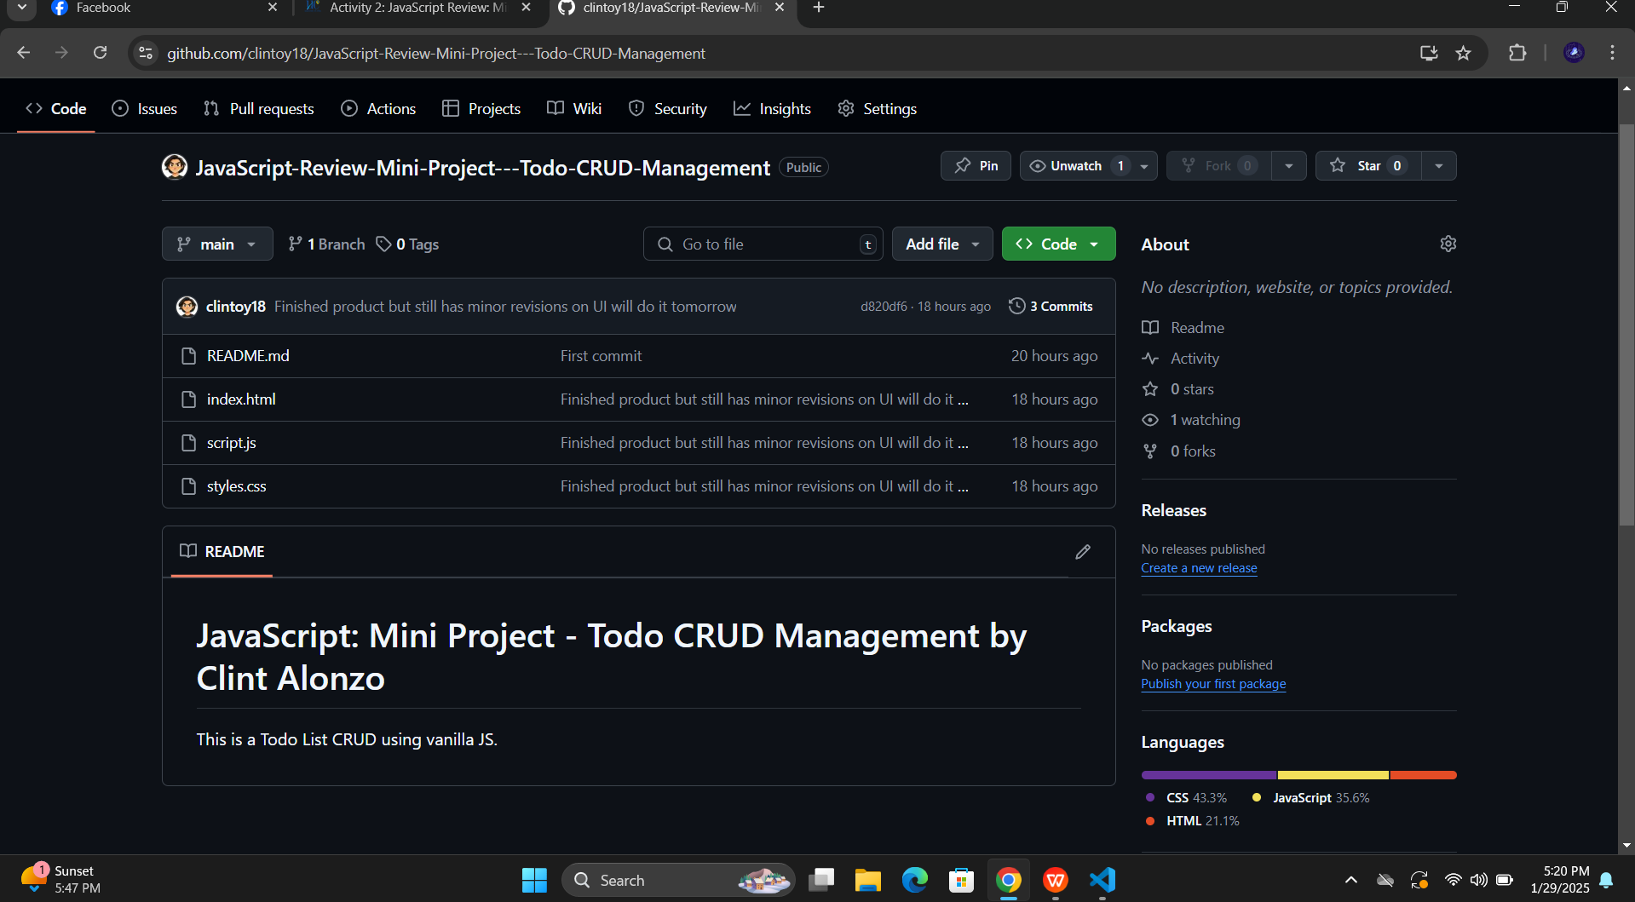

<https://github.com/clintoy18/JavaScript-Review-Mini-Project---Todo-CRUD-Management.git>

Link is also in text file. Thank you sir. Learned something new today.